X = funny monkey

Print(x.title())

* This will capitalize the first letter in each word

Output: Funny Monkey

* Will also capitalize the letters after apostrophes
* Will capitalize every letter in that phrase/sentence

List of commonly used string methods

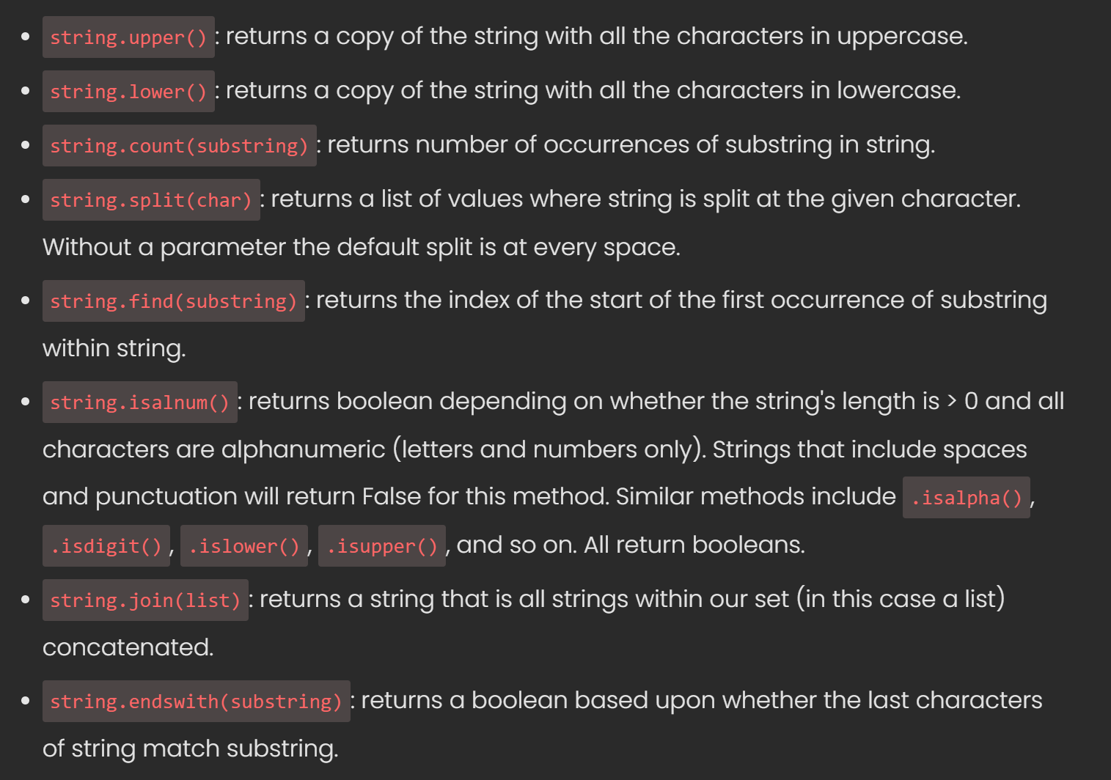

OFFICE HOUR

LECTURE